**How to Set Execution Policy in Windows PowerShell.**

Following Steps to set Policy to run scripts in the system.

**Step 1**: On Command Line Write “Get-ExecutionPolicy” or “get-exe[TAB]”.

This will check the current system policy setting.

E.g. “Restricted” means you cannot run scripts.

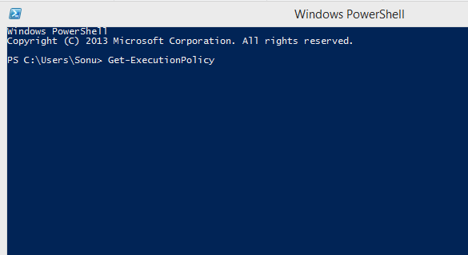

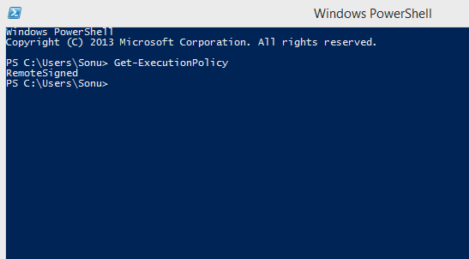

**Step-2**: Next Command is “Set-ExecutionPolicy –Scope CurrentUser”.

As Soon as you hit enter you will be asked what policy do you want for the current user.

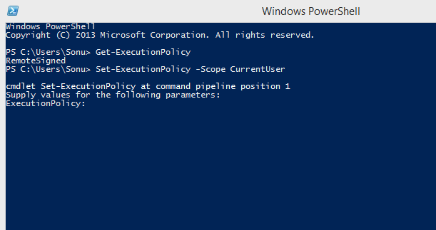

You Have Four Options.

* **Restricted** - No scripts can be run. Windows PowerShell can be used only in interactive mode.
* **AllSigned** - Only scripts signed by a trusted publisher can be run.
* **RemoteSigned** - Downloaded scripts must be signed by a trusted publisher before they can be run.
* **Unrestricted** - No restrictions; all Windows PowerShell scripts can be run.

**Step-3**: Confirmation to the Change Policy

1. Yes
2. No
3. Suspend
4. Default is Yes If you hit enter.

